**INDIAN INSTITUTE OF TECHNOLOGY, BOMBAY**

**Department of Metallurgical Engineering and Materials Science**

**MM 202: THERMODYNAMICS : 2019-20: Fall**

**Tutorial No. 9: Date: Oct 15, 2019**

1. (a) From vapor pressure data at 1550 C the following data has been found for the Ni − Fe solution (data adapted from Gaskell). Complete the table.

|  |  |  |  |  |  |  |  |  |  |  |  |
| --- | --- | --- | --- | --- | --- | --- | --- | --- | --- | --- | --- |
| item | data | | | | | | | | | | |
| X_Ni | 1.0000 | 0.9000 | 0.8000 | 0.7000 | 0.6000 | 0.5000 | 0.4000 | 0.3000 | 0.2000 | 0.1000 | 0.0000 |
| X_Fe |  |  |  |  |  |  |  |  |  |  |  |
| a_Ni w.r.t. pure l | 1.0000 | 0.8900 | 0.7660 | 0.6200 | 0.4850 | 0.3740 | 0.2830 | 0.2070 | 0.1360 | 0.0670 | 0.0000 |
| γ_Ni |  |  |  |  |  |  |  |  |  |  |  |
| ln(γ_Ni) |  |  |  |  |  |  |  |  |  |  |  |
| αNi |  |  |  |  |  |  |  |  |  |  |  |

1. Using Gibbs −Duhem equation, find γFe at XFe = 0.40. Use the trapezoidal rule for integration.

ln γFe|XFe = 0.4 = −αNi XNiXFe +

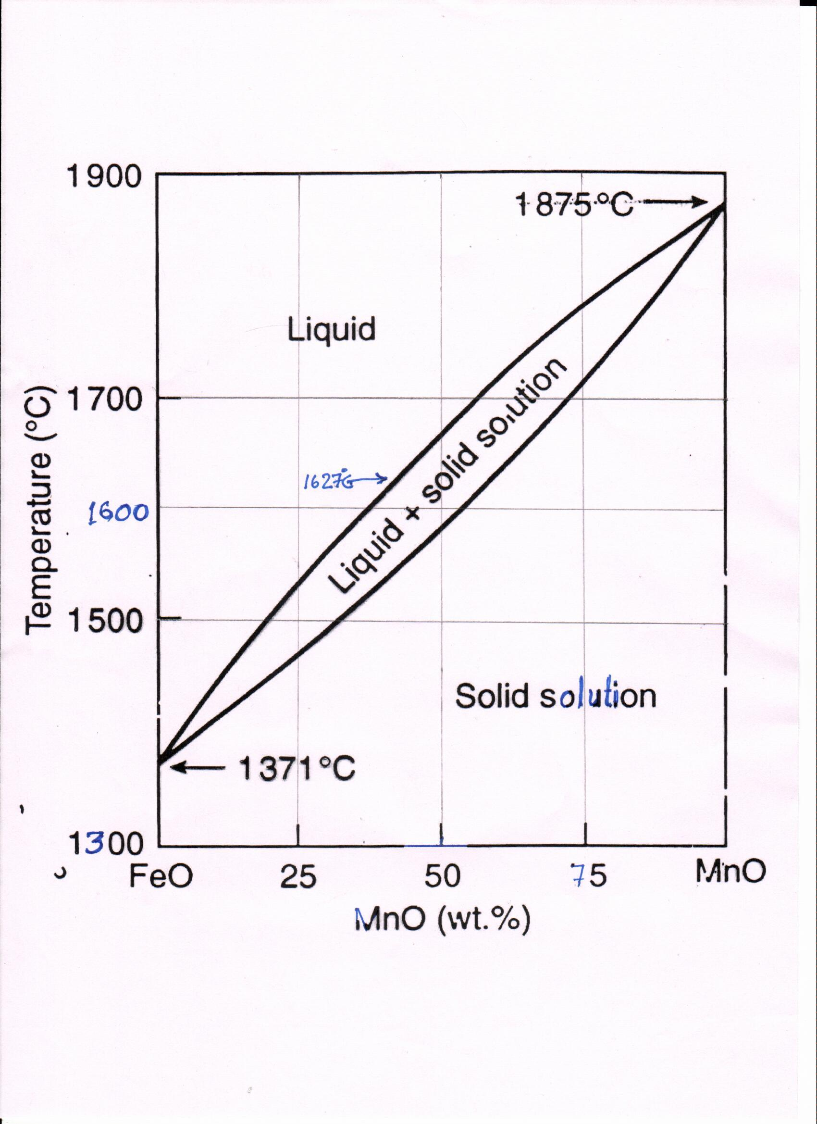

1. A Fe-Mn alloy liquid alloy contains 0.02 atom % Mn. It is in equilibrium with an oxide solution of FeO-MnO at 1873K. Is the oxide solution liquid or solid?

Mn may be assumed to follow Henry’s law in iron, with γoMn = 1.30 at 1873K. FeO liquid is stoichiometric. So is MnO liquid.

[HINT: O2 should be in equilibrium simultaneously with Fe-FeO and Mn-MnO systems. Assume solid solution, solve and get the composition, and verify whether it is liquid from the phase diagram.